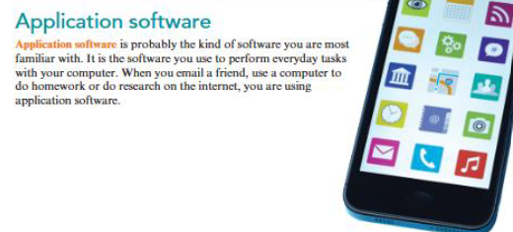

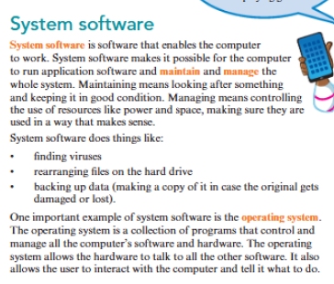

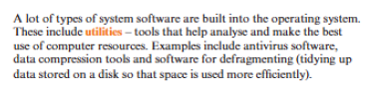

**Do the following questions on MS Word and email the document to the following email address:**

[**digitalcubiclepk@gmail.com**](mailto:digitalcubiclepk@gmail.com)

**Deadline: 22nd August 2025**

**Q1. What are two examples of system software?**

**Q2. What is the purpose of system software?**

**Q3. What are two examples of application software?**

**Q4. What is the purpose of application software?**